This document is designed to present the frontend Datamart visibility
Three-staged layer architecture:
- Staging Layer
- Transformation Layer
- Reporting Layer
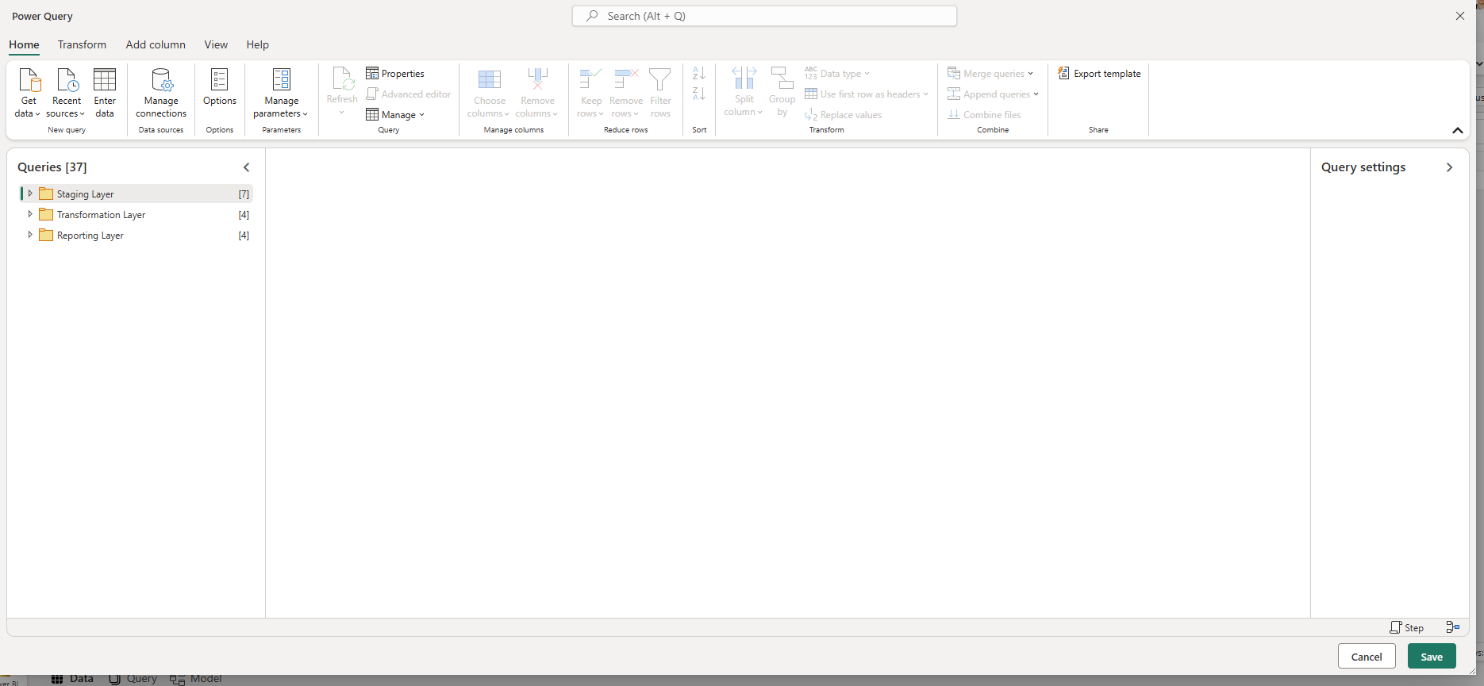

Staging Layer is designed to present raw sources of data (import to staging):
Staging Layer
- Last Refresh Table
- GA_2025
- GI_API_staging
- BL_API_staging
- Assets_API_staging
- GP_API_staging
- RLS
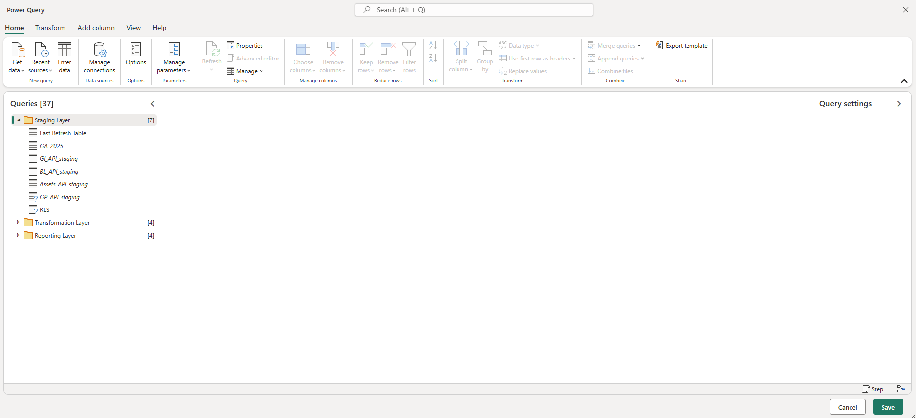

Transformation Layer is designed to present transformations for each report in a designated folder.
Transformation Layer
- Global Industries report
  - GI_Users_dataset
  - GI_API_transformation
  - Index_GI
  - GI_Pageviews_dataset
- Business Lines report
  - BL_Users_dataset
  - BL_API_transformation
  - Index_BL
  - BL_Pageviews_dataset
- BL Content report
  - BL_API_content_transformation
  - Index_BL_content
  - Assets_API_content_transformation
- Group Priorities report
  - GP_Users_dataset
  - GP_API_transformation
  - Index_GP
  - GP_Pageviews_dataset
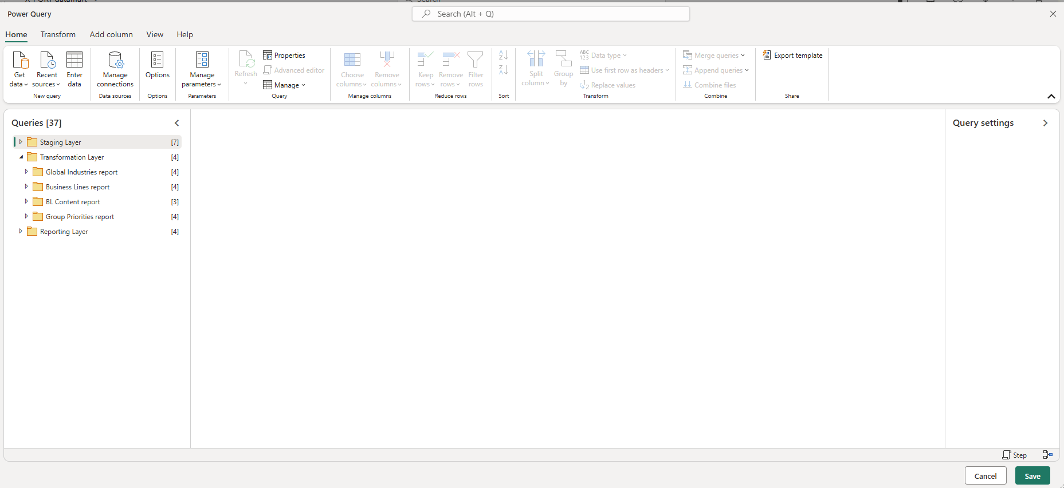
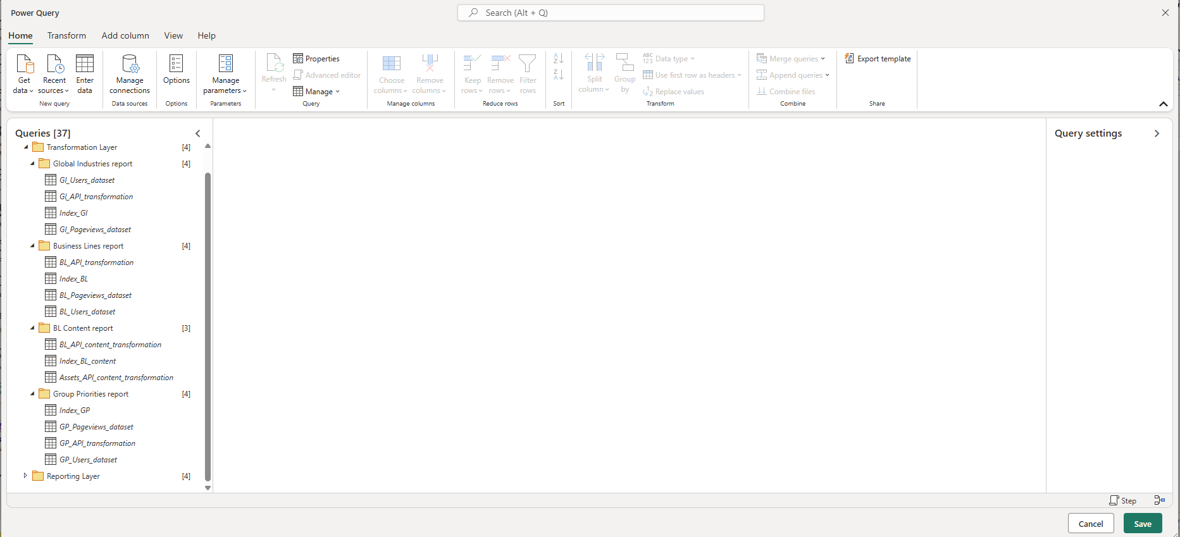
Reporting Layer is designed to present final queries for each report in a designated folder.
Reporting Layer
- Global Industries report
  - GI_Users_dataset - r
  - GI_API_transformation - r
  - Index_GI - r
  - GI_Pageviews_dataset - r
- Business Lines report
  - BL_Users_dataset - r
  - BL_API_transformation - r
  - Index_BL - r
  - BL_Pageviews_dataset - r
- BL Content report
  - BL_API_content_transformation - r
  - Index_BL_content - r
  - Assets_API_content_transformation - r
- Group Priorities report
  - GP_Users_dataset - r
  - GP_API_transformation - r
  - Index_GP - r
  - GP_Pageviews_dataset - r

